Let me start my story by giving you a little bit of background. I'm from Texas- born & bred. The area where I grew up rarely saw single digit temperatures in the winter, much less significant snow accumulations. I met my Geo-buddy, Magnet Man, after finding one of his hides & reading the cache page which described how he had just moved to Cincinnati from Dallas. Since he lived less than 5 miles from me & was a fellow Texan, I felt we needed to join geo-forces.

My story beings on the day after a major winter storm had hit the Cincinnati area. It was the second or third snow storm to drop huge amounts of the white death on us. Drifts in some places were a couple feet deep. Since it was a snow day Magnet Man & I decided to chase after an elusive FTF that had been giving some local cachers problems.
The cache was located at the lake about 1.5 miles from the parking area, in the middle of a pond and up in the top of a tree. Did I mention all the snow on the ground? Oh and the temperature was 15 degrees and dropping! A smarter cacher may have seen these challenges as a deterrent.. but not Visiting Vet Tech or Magnet Man! On Friday morning, January 21, 2011, we suited up in multiple layers of our warmest clothing, put on our snow boots, grabbed the GPS & headed out for an adventure.
The state park was empty. I parked my trusty geo-mobile in a parking area about 2 miles from Ground Zero. There was a dirt road that had been closed that headed in the general direction of the cache, so away we went. I discovered quickly that my top most layer of clothing was going to be a hindrance for me. I had on a pair of insulated coveralls that buttoned down the legs. With all the layers of pants I had on, the buttons wouldn't close all the way down, so I had to leave them open from my knees to my ankles. This caused my legs to have a "shovel" affect on the snow I was walking through. I was unable to pick my feet up very high & instead had to push through the snow. Needless to say after a few hundred yards my legs were jello. We trudged on; however- there was an FTF just waiting to be found!
The dirt road ended and became a walking trail 7/10ths of a mile in. The trail was mostly frozen mud and lots of snow. The drifts were past my knees in most places. The trail was narrow and invisible branches and thorny bushes kept tripping us up. It was very hard, slow going. After 2 hours of seriously tough hiking, we made it to a pond in the middle of the woods. We were both sweating, and since the temperature had been steadily dropping, our sweat was becoming ice on our hair & skin. We sat at the edge of the pond & pondered how we would retrieve that cache. Neither of us had thought about bringing any sort of flotation device to cross the frozen pond. Being from Texas I had never seen a pond freeze before. I wasn't sure how thick the ice was or if it was safe at all. I've seen the news reports of people falling through ice, and although this was only 3-4 foot deep, I didn't' want to get wet!
There was a fallen tree branch about 4 inches in circumference that spanned a large part of the pond from the bank where we sat. I gingerly tested it and it seemed pretty solid. Fearing a watery end, I removed all but one layer of clothes and started my way down the branch. After a few feet, the branch still felt pretty solid so as carefully as I could (and thinking about feathers and cotton fluff) I stepped onto the ice. It held! I'm not sure how thick it actually was, but I was able to walk on it all the way to the island. I reached the island safely and Magnet Man started following me. The island itself was only about 20 foot wide. There were 3 or 4 pine trees growing on it, so I started looking at the most likely hiding spot. I chose a tree that looked pretty easy to climb and up I went. The cache was actually in the tree I choose, at the very top past a bunch of briars. The higher I went up the tree the more it swayed. It wasn't a very big tree to begin with so it had be pretty nervous. I grabbed the cache & with frozen fingers opened it up to find that there were no signatures---FTF! We both signed and returned the container to the tree, then made our way back to the banks of the pond. I put the other layers of clothes back on & we took some pictures standing on the ice (Texans remember? We'd never seen anything like it). Grabbing the cache once we reached GZ didn't' take too long, but the whole adventure took almost 5 hours. All in all we hiked just under 5 miles on those snowy trails, feet deep in drifts, and in single digit temperatures. The temps started at 15 but by the time we made it back to the care it had reached 7. The snow started again as we were driving home. I have never been on a caching adventure where I was more worn out afterward, or had as much fun! Thank you for giving me the opportunity to remember and share my story.
Jedi mind tricks, the Art of Levitation- GC2MJ0Y , FTF 1/21/2011
Visiting Vet Tech (aka Frankie Burns)

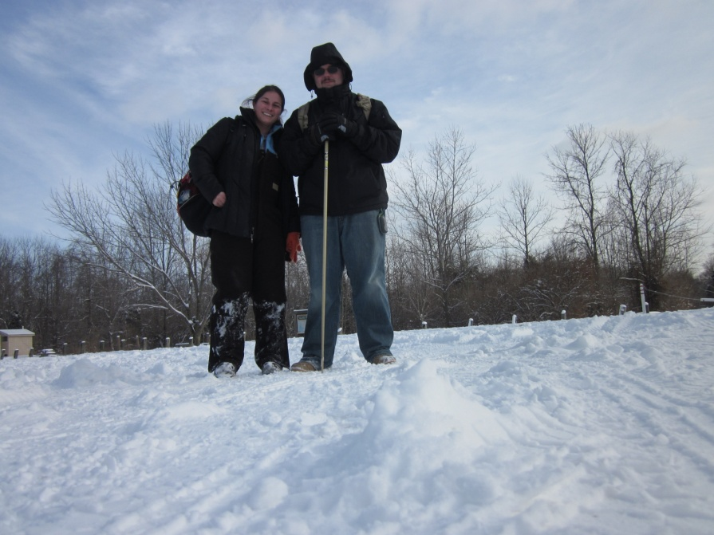
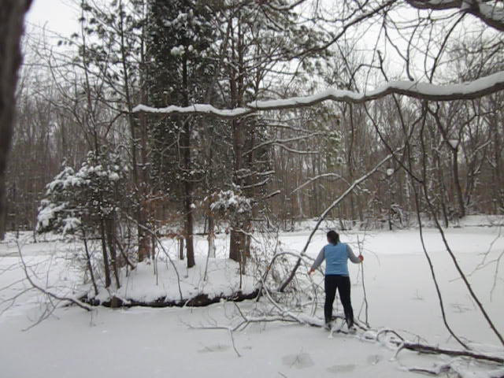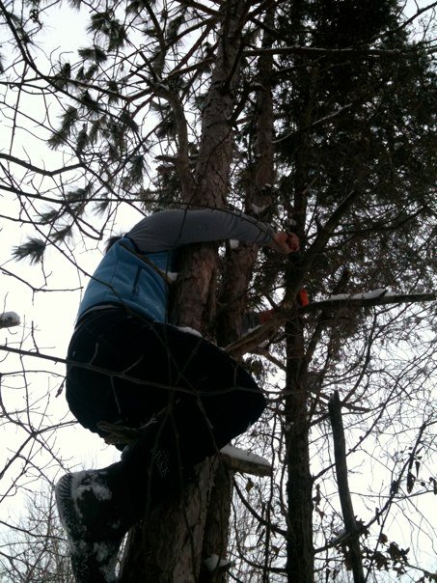
Grabbing the cache & a view from the top as Magnet Man signs
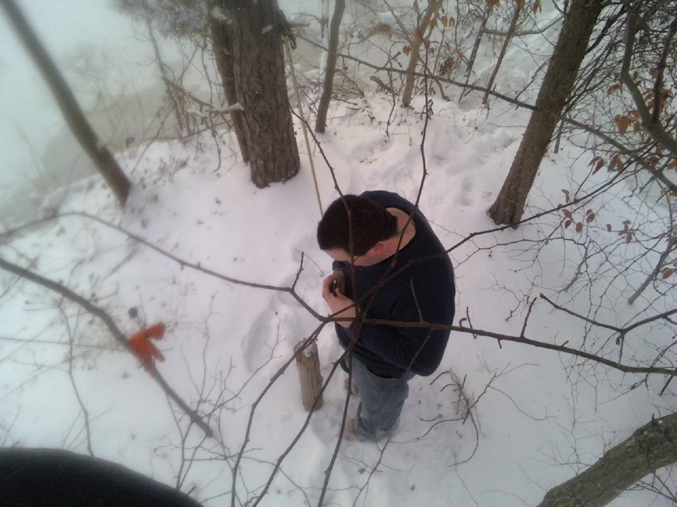 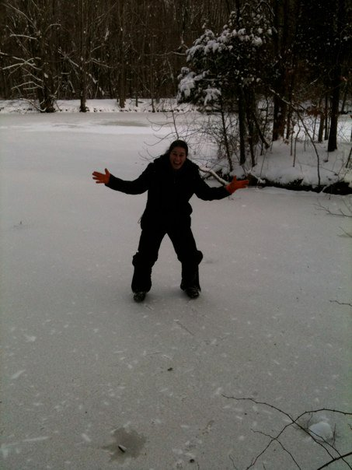 OMG- A frozen pond!
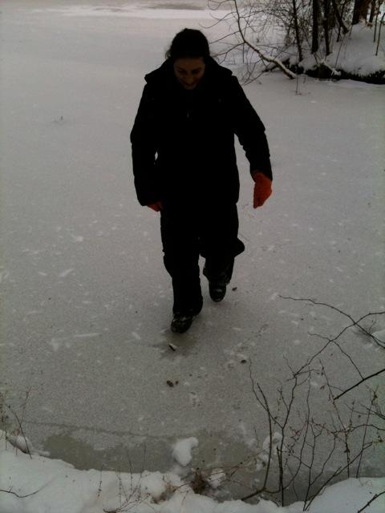
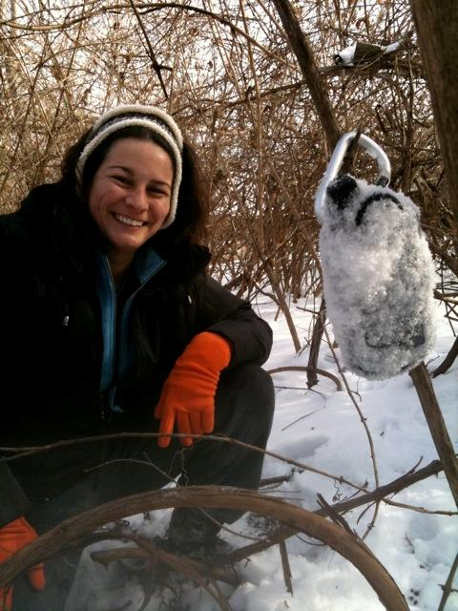
I dropped my GPS in the snow & thought I'd NEVER find it, but i did!

